2016届“六校联盟”高三第四次联考
英语试题参考答案及评分标准
第二部分 阅读理解（共两节，满分40分）
21-24 BACB 25-27 ABD 28-31 CABC 32-35 CDDA 36-40 DGCFA
第三部分 英语知识运用（共两节，满分45分）
第一节 完型填空（共20小题；每小题1.5分，满分30分）
41-45 BACCD 46-50 CACBA 51-55 DDABD 56-60 BADBC
第二节 语篇填空（共10小题；每小题1.5分，满分15分）
61. does 62. useless 63. obviously 64. its 65. respond / responding
66. comments 67. happier 68. in 69. a 70. or
第四部分 写作（共两节，满分35分）
第一节：短文改错（共10小题；每小题1分，满分10分）
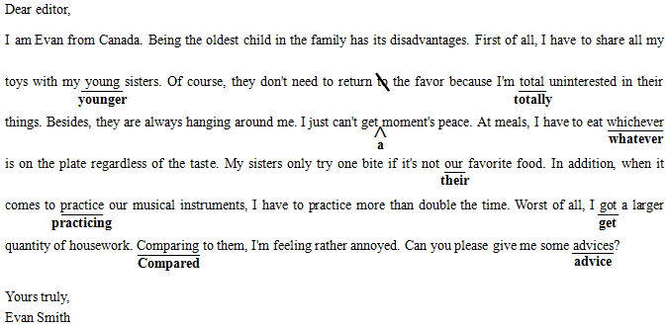
第二节：书面表达（共1小题；满分25分）
Dear Mary,
I have learnt that you are curious about the after-class activities among students in our school. And I’m writing to show you the rich and colorful campus life.
Our school distinguishes itself for organizing a wide variety of activities, which contributes to our all-round development. Among them, the annual singing competition stands out as our favorite, which enjoys widespread popularity among students. We can sign up solo or in teams and some of us even create our own music. This year, with the theme of “Chinese style”, the competition has included many traditional Chinese elements such as ancient costumes, songs adapted from poems. These all have exerted a profound impact on shaping our character.
I wonder what activities students in your school are engaged in. I’ll be more than grateful if you could share some interesting experiences with me.
I’m looking forward to your reply.
Yours
Li Hua

